**Offline Eclipse**



**Imran Naseem**

**Learn How To Make $500-$1000 By “Website Leasing”**

Hello and welcome to a special offline cash cow report – Offline Eclipse.

In this report I am going to show you a powerful method of making money from local business owners. By far this is the best method of making money from business owners because it is not only lucrative but there are so many different avenues you can take with this method.

The offline niche is very lucrative right now and there is a ton of cash to be made. Local business owners are constantly in need of help and most of them are not going to have a clue about Internet marketing. In fact just the other day one of my friends set up a café in the local area and he asked me to find out if anyone can design a logo and website for his business. Rather then refer him to someone I managed to get him to say yes to my service ;)

In this report I am going to show you step by step on how to go about setting up a website leasing service. The beauty of this strategy is that you can also outsource this process.

In order for this method to work you will need to make sure you do the proper research before you go about contacting local business owners. I will show you an easy way to profit from this method and how to set up a constant stream of residual income from lots of different business owners.

I hope you enjoy this cash cow report and I hope you continue to have faith in all my future cash cow reports.

<http://www.ImranNaseem.com>

**Getting Started**

The first thing you need to do is understand what I mean by “Website Leasing”. Now Website Leasing is simply an **agreement** between the user and the owner whereby the “privilege of using a website is offered in exchange for regular payments”.

Now website leasing is another way to “rent” a website. Now I am sure you might be aware of this business model before but I am going to show you exactly how to go about approaching business owners in offering a website leasing service.

Local business owners are constantly spending thousands and thousands of dollars on website development and some are still struggling to generate any good response. Just because a business owner has a website does not mean they will start generating clients or leads straight away.

By offering a website leasing service you are not only going to save them a lot of money but you will also be able to justify your service and offer it to business owners who would be in a position to say “yes” to the service.

Also it is a win-win situation if you offer a website leasing service as you can get the site on the first page of Google and monetise it for the business owner – thus making sure it “Google-Ready”.

The first thing you need to do before offering a website leasing service is to research your market. Now there are lots of different categories of business owners out there. However, from my experience certain markets respond better as opposed to other markets.

Local businesses are always going to be competing against each other if a certain business is in their market.

The first thing you need to do is keyword research to see what people are typing on Google – this is also known as local SEO.

So the first thing I am going to do is type in the keyword.

In this case I am going to focus on “florists”.

I type in “Florists” on Google.

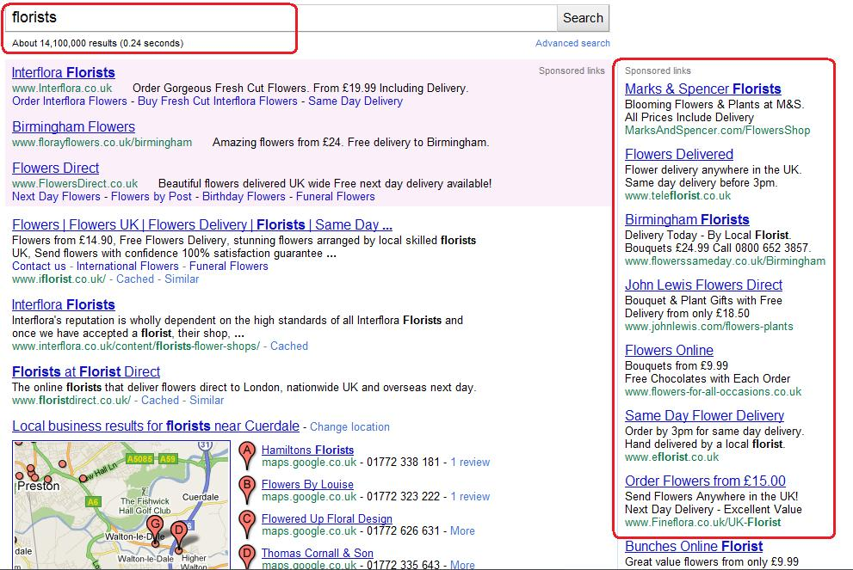

The first thing you should notice is that there are a TON of advertisers who are competing for this keyword.

That means all of these businesses who are competing for the keyword “florists” are simply wasting their money. They are not targeting their business towards a specific location.

Here is a [Florist](http://www.flowerssameday.co.uk/default.asp) (based in Birmingham) who is using Google Adwords to get their message across.

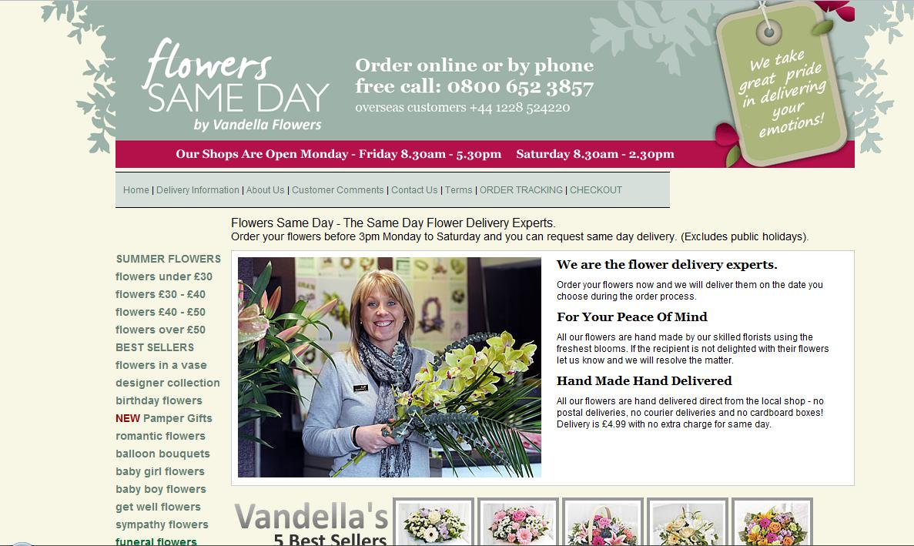

The first thing I am going to do is see if this website is listed on the first page of Google for the main keywords “Florists Birmingham” and “Florists in Birmingham” or “Birmingham Florists”.

(It is important to exhaust all the different combinations of the different keywords).

***“Florists Birmingham”***

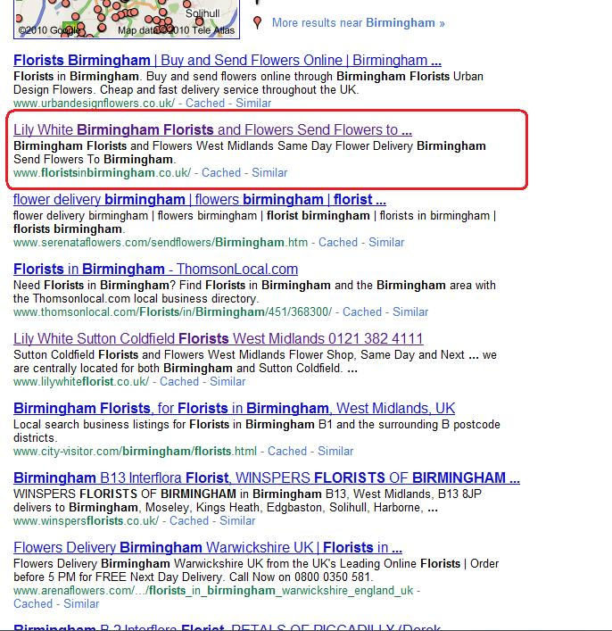

We can see that the website is nowhere to be found on Google. However, what is interesting is the website “floristsinbirmingham.co.uk” appears on the first page.

Why does this appear on the first page of Google?

Simple.

It has a good keyword rich domain (more on this later).

***“Birmingham Florists”***

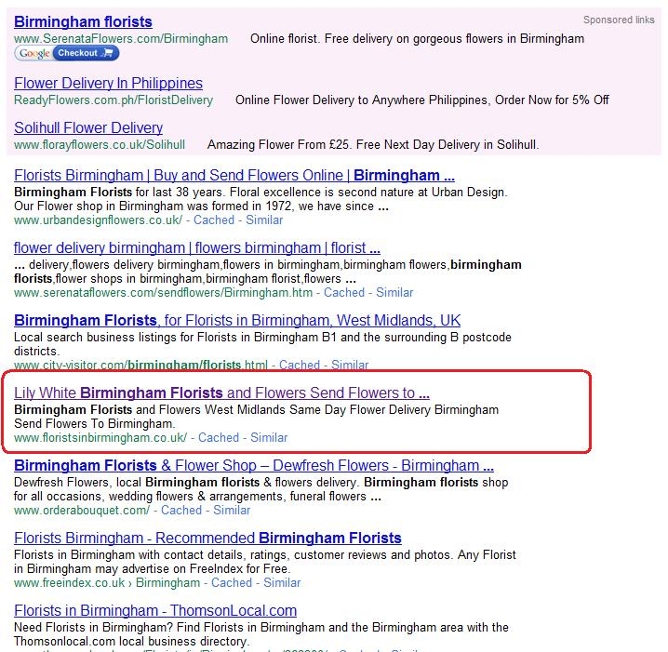

We can see we get similar set of results for this keyword and the other keyword. The keyword rich website appears on the first page.

Now the next thing I am going to do is check on the number of searches for the keywords “Florists Birmingham”.

Now I am going to use Google Keyword Selector Tool to see the accurate number of estimated searches for this keyword. Remember data like this is a goldmine to a business owner as they do not know how to do keyword research.

This is your chance to impress them by gathering this data.

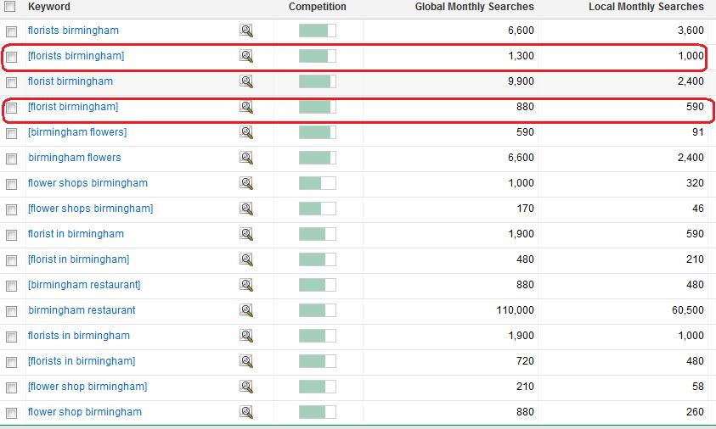

Now we can see that the exact phrase (in quotes) generates just over 1300 searches a month (which is pretty high when we are talking about local SEO searches).

So in general there are a lot of searches for the keywords that centre around “Florists Birmingham”.

The next thing to do is see if there are any good **keyword rich domain names** remaining.

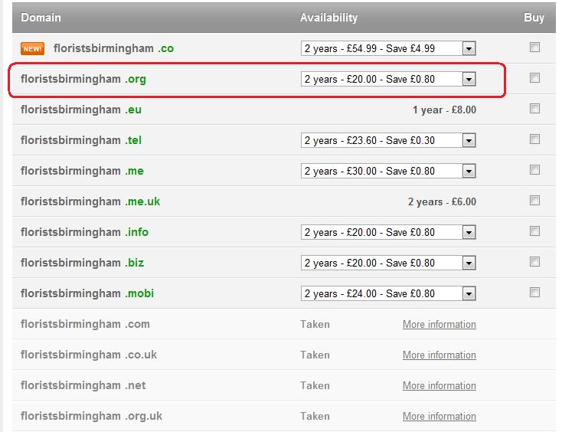

As you can see the **.org is available** (this is a good domain name) as it is well ranked on the search engines.

The rest of the keyword rich domains are already taken as you can see.

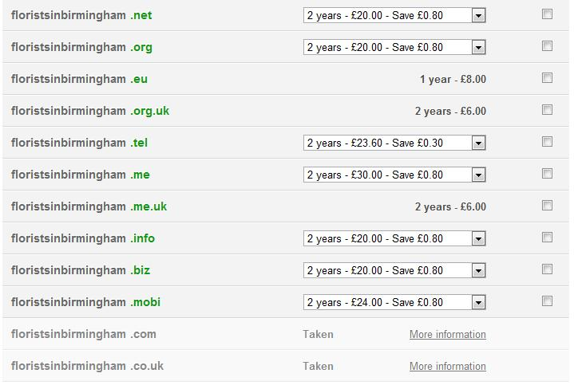

Here is another set of domains. As you can see the .org and the .net are available and they too make excellent keyword rich domains.

Now let’s look at the keyword rich domain website that appears on the first page for the keyword “florists in Birmingham”.

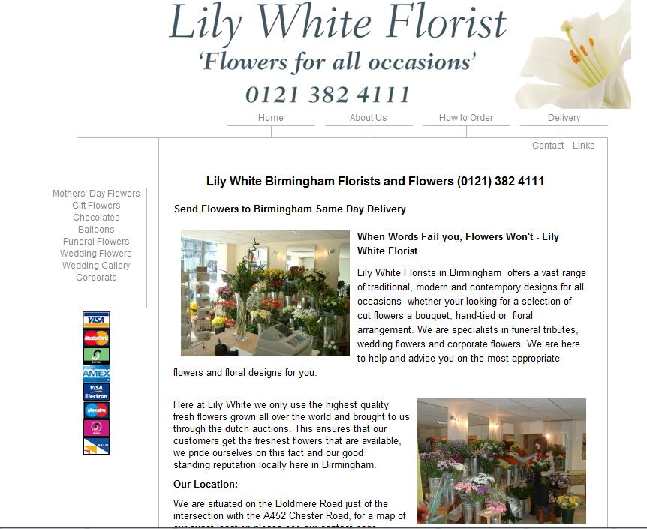

We can see that this website is acting like a portal and is a perfect example of a “lease”. The company is paying a monthly fee to appear on the first page of Google.

The owner of the [website](http://www.floristsinbirmingham.co.uk/) (in this case you) will usually make sure it is kept up to date and ensure it stays on the first page. If rankings drop then you can simply ask the business owner to cease payments.

Now in this report I am going to do a **step-by-step** account on how to go about doing this.

Now the first thing you should understand is that there are lots of categories of business. Here are all the different categories.

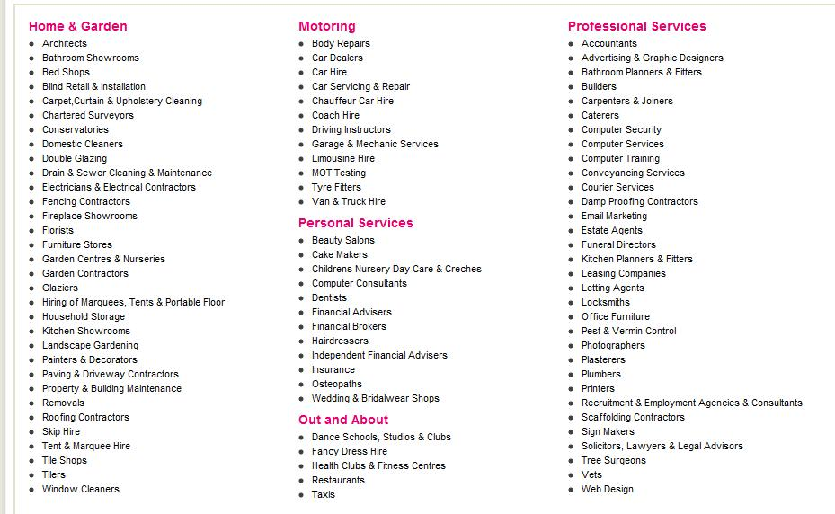

As you can see these categories are all divided into different services.

I would select a category then just focus entirely on that category until you dominate it.

So for example, lets say I wish to focus on “Limo Hire” in a specific area the first thing I would do is simply type in “Limo Hire on Google and see all the different companies who are using Google to advertise their Limo Hire business.

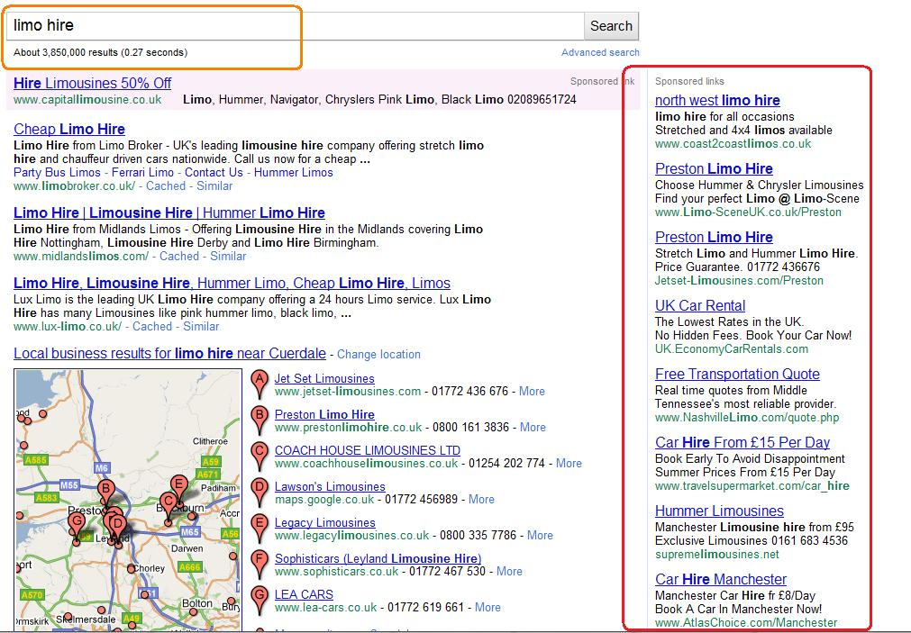

As you can see there are a ton of Limo Hire businesses who are advertising with Google. These guys are paying $$$ (over a $dollar per click!).

The first thing I am going to do therefore is do **keyword research** before I register a domain name to see what people are looking for in a specific place.

I am going to use [Google Keyword tool](https://adwords.google.co.uk/o/Targeting/Explorer?__u=1000000000&__c=1000000000&ideaRequestType=KEYWORD_IDEAS) to see what people are typing in regards to “Limo Hire” (in a specific location).

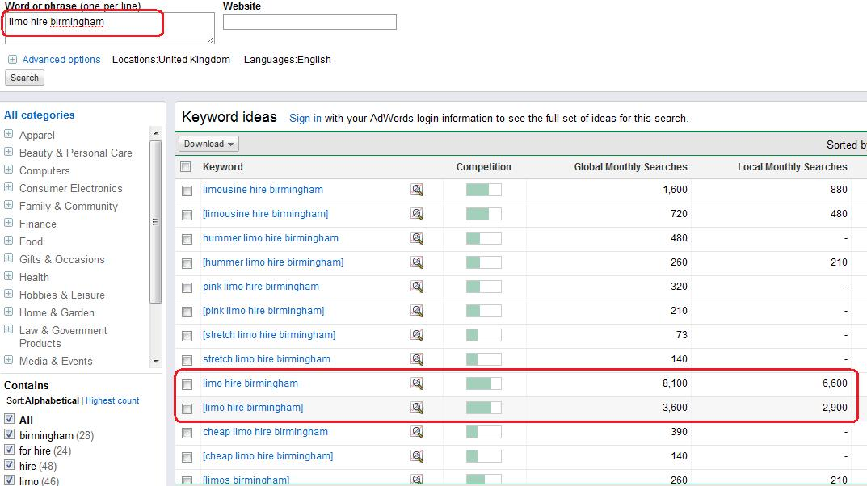

As you can see there are thousands and thousands of searches for “Limo hire Birmingham”.

This is good news and this means people are typing this on Google.

People are looking to hire a limo in the “Birmingham” area.

Now I am going to see which **keyword rich domains** are available.

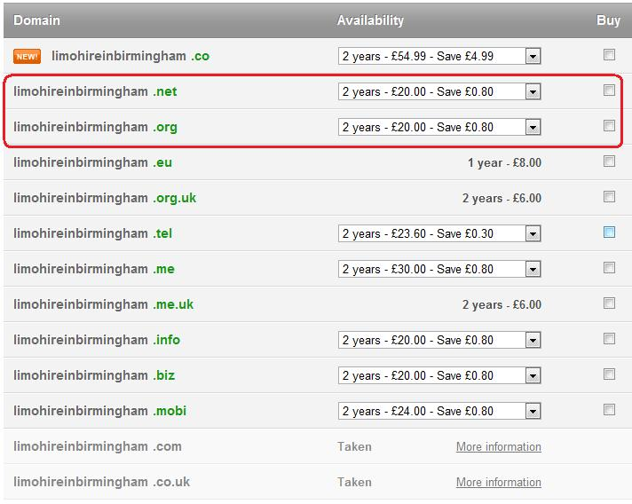

As you can see two domain names are available that are keyword rich. I am going to go ahead and purchase the .org domain name.

(.net domain names are also good in terms of ranking on Google).

The next thing you need to do is build your leasing site – once you have purchased your domain name.

There are several different tools you can use to build your website leasing site.

I highly recommend you use any of the following services to create your leasing website.

**Create**

[Create](http://www.create.net) is an excellent service that I have used to lease client’s websites. This service is easy to use and it costs just over $20 a month to use their templates and create a simple powerful site in no time.

The only downside of this service is that it does not allow you to host unlimited domains. So if you are going to be leasing a website to a client then you will need to sign up again. There is also an option to remove their footer on your website.

This is a great service, overall.

**Wordpress Site**

By far this is the most popular and the one that many people end up using because it has lots of features and lots of widgets available.

**X-Site Pro**

[X-site Pro](http://www.xsitepro.com/) is powerful when it comes to creating quick websites for SEO purposes. The cost of X-Site pro is just $197 but it is worth it and has a lot of features.

For the purposes of this website I am going to stick to my Wordpress simple one paged website.

I tend to use the classic Wordpress theme – (see below).

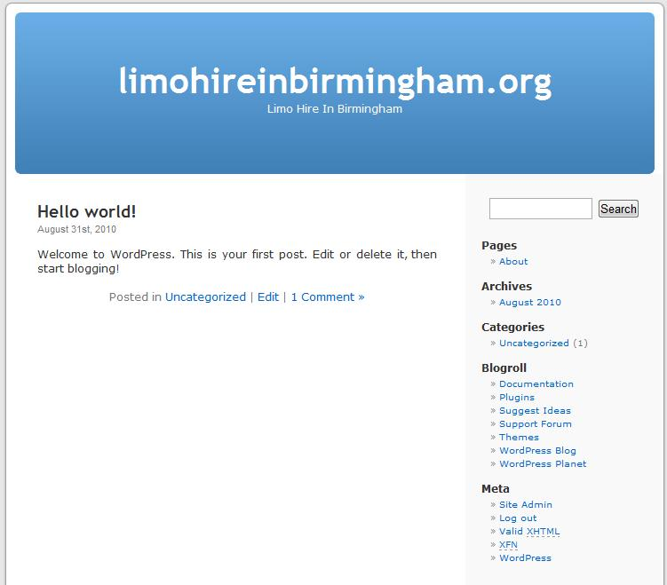

Now at this stage I am going to start adding content to the website. But before I do that I am going to install several Wordpress plug ins for SEO purposes.

These plugs in are the following.

**All in One SEO Pack** - <http://wordpress.org/extend/plugins/all-in-one-seo-pack/>

Configuring this plug in is pretty easy. Notice how I have added all the different combination of the keywords.

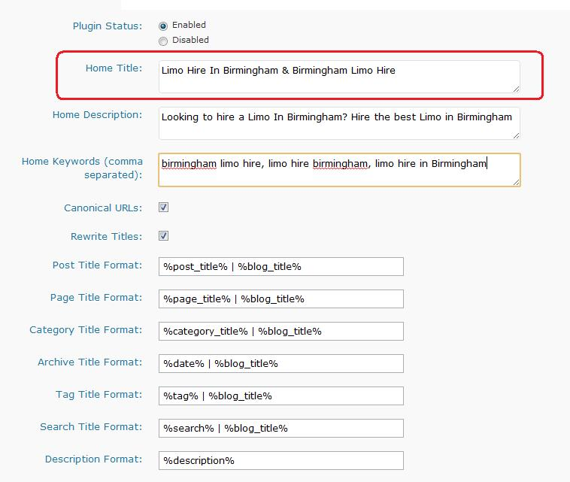

As you can see I have added all the different combinations of the keywords.

***Birmingham Limo Hire***

***Limo Hire Birmingham***

***Limo Hire in Birmingham***

**Exclude Pages -** <http://wordpress.org/extend/plugins/exclude-pages/>

This is another important plug in which makes sure your website’s posts are indexed on the search engines.

When it comes to the search engines we need to be making sure that our website tells the **search engines exactly** what it is and what the content contained within is about.

Once we have this right, which will come from the **on page optimisation** and content, we need to **build backlinks to** our website which increases the popularity of our website in the search engines eyes and lifts us up through the rankings.

Now, this is the usual thing for a standard HTML website which is easily read by Google and other search engines the majority of the time.

Simply setting up a Wordpress keyword rich website will not guarantee you to get on the first page of Google.

In order to get on the first page we need to make a few changes to our website.

The first thing you need to do is add content to the homepage. As you can see I have added some content to the homepage making sure I have included the keyword several times in the content.

In this case the main keyword is “Limo Hire Birmingham”.

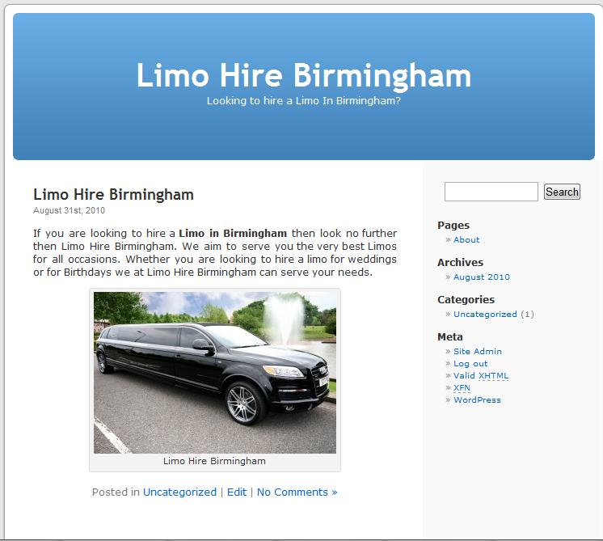

Now at this stage make sure you include relevant content.

The content needs to also mention the keyword several times for SEO purposes.

Also make sure the title of your website contains the keyword.

When it comes to writing content make sure that you include variations of your keyword within the first paragraph and the last paragraph or sentence.

**Contact Page**

Also once your site is showing up on the first page you will need to make sure you have a contact form or a page where people can reach you to email you for enquiries in regards to your leasing service.

There is a plug in called Contact7 - <http://contactform7.com/> you can use to add a contact form to your page. This will enable business owners to contact you via email if they wish to lease your website.

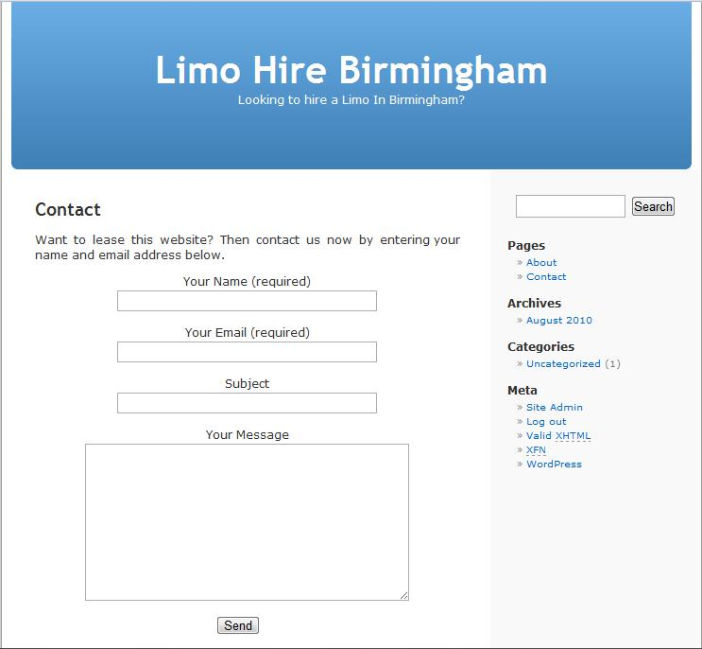

I would also add several “call to action” features such as a landing page, social media icons and other features (more on this later).

Once you have added the content to your keyword rich website the next thing you need to do is getting it indexed on the search engines so that it ends up appearing on the first page on Google.

**Directing traffic to your Keyword Rich Website**

The next thing to do is direct traffic to your website so that when it comes to offering your leasing service you can easily sell this to the business owner without having to prove anything.

Now there are several ways you can do this.

The first thing I am going to do is use my Google News service and post an article on my website at – [www.newstoday365.com](http://www.newstoday365.com)

(If anyone wants to use my Google News service then I charge $10.00) – this is excellent for backlinks and getting your site indexed fast.

Here is the exact article I wrote - <http://newstoday365.com/limo-hire-in-birmingham/33627/> so my site starts generating Backlink juice straight away.

Here is the [link to my article](http://newstoday365.com/limo-hire-in-birmingham/33627/) – as you can see it is on Google News for the main keyword.

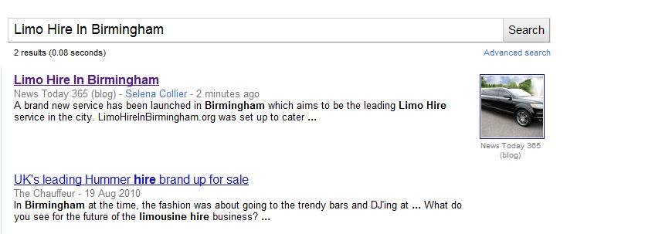

Now for SEO purposes this will be good and very powerful.

This will get your site straight away on Google and Google will start sending its spiders to your site.

Another way to generate link juice for your website is to use PROFILE backlinks.

There are a ton of services on Odesk and Elance that you can use to hire people to post your site to social bookmarking sites with high PR.

Simply head over to [Odesk](http://www.odesk.com) and post an ad.

Profile backlinks will get your site ranked high on the search engines for your main keyword. This will give you a clear leapfrog over other websites.

The main experts in Profile links were Angela and Paul. They had a successful service running on the Warrior Forum.

**Web 2.0 Links**

Web 2.0 links are also powerful because they are one way backlinks and you can simply outsource this process too.

The sites I recommend to do this with are the following:

[www.blogger.com](http://www.blogger.com)

[www.squidoo.com](http://www.squidoo.com)

[www.hubpages.com](http://www.hubpages.com)

[www.weebly.com](http://www.weebly.com)

[www.wetpaint.com](http://www.wetpaint.com)

[www.scribd.com](http://www.scribd.com)

[www.livejournal.com](http://www.livejournal.com)

[www.wordpress.com](http://www.wordpress.com)

What you need to do is simply hire someone to create content for your keyword rich website then link it to your website. Web 2.0 links are excellent for one way traffic.

Article directories are also good when it comes to building links for your keyword rich website. Directories such as [Article Base](http://www.articlesbase.com/) and [Ezine Articles](http://www.EzineArticles.com) are great for long-term traffic and helping your site jump position in the search engines.

The advantage of having a keyword rich domain and using the above SEO tactics will greatly help your site **dominate** the first page of Google.

**Spying on your Competitors**

When trying to achieve first page rankings on Google I also tend to use a service called [SEO Quake](http://www.seoquake.com).

This service is excellent if you wish to see the number of backlinks and page rank of your competitor.

For example, if I type in “Limo Hire Birmingham” on Google and activate SEO Quake we can see the following information for this website.

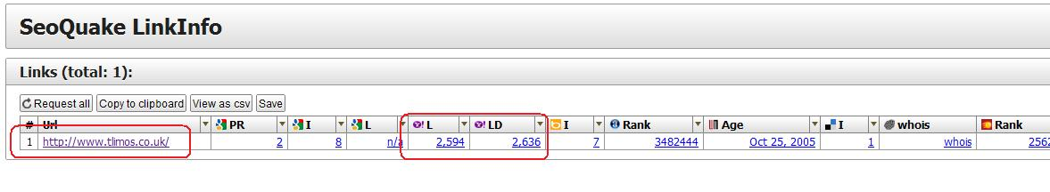

We can here get a good indication of the number of backlinks and the page rank of the website. We can see that this website has just ONE social bookmarking link.

Once your site hits the first page of Google you are now ready to create a Leasing package to sell to the Local business owner.

In the next section I am going to show you how to add value to your leasing service and how to create a package – based on the type of leasing package you offer (including the prices).

All of these prices will reflect a monthly residual aspect to it.

**Different Packages For Your Leasing Service**

The next thing to do is offer a package for your website leading service. A package will give the business owner an option to choose the best type of leasing service for them. Some business owners will want to choose from a range of different packages so they can fit their needs.

Here is an example on how you can structure your package.

**Website Leasing Package A - $97.00 A Month (Bronze)**

Our Bronze package consists of the following

* Exclusive domain name
* Free Hosting
* Online Support
* Autoresponder
* Stat tracker

**Website Leasing Package B - $127.00 A Month (Silver)**

Our Silver package consists of the following

* Exclusive domain name
* Free Hosting
* Online Support
* Autoresponder
* Stat tracker
* Free Social Media Functions Incorporated
* FREE Consultation (30 minutes)

**Website Leasing Package C - $197.00 A Month (Gold)**

Our Gold package consists of the following

* Exclusive domain name
* Free Hosting
* Online Support
* Autoresponder
* Stat tracker
* Free Social Media Functions Incorporated
* FREE Consultation (60 minutes)
* Telephone support
* FREE Google News publicity for your website
* FREE Backlink Traffic Package

Now this is just a rough breakdown of what kind of package you can come up with.

Here is a screenshot of the prices of a company offering a website leasing service. Notice all the fees are monthly.

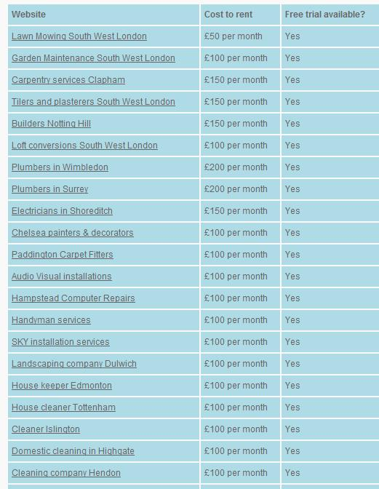

If you can get 20 business owners to pay $197 then that is **$3940** residual income ☺

If you can get 50 business owners paying $197 then that works out at $9850 a month.

**Presenting your offer to the business owner**

Once you have come up with your package you need to present your offer to prospective business owners. Now I use a range of techniques that involve cold calling, flyer marketing and also email marketing.

However, I only use email marketing if a business owner requests a “follow up email”.

My strategy **is simply looking for business owners who are NOT** on the first page of Google for their keyword and are advertising with Google Adwords (thus wasting money).

So for example, going back to our Limo Hire website the first thing I am going to do is head over to Google and type in “Limo Hire”.

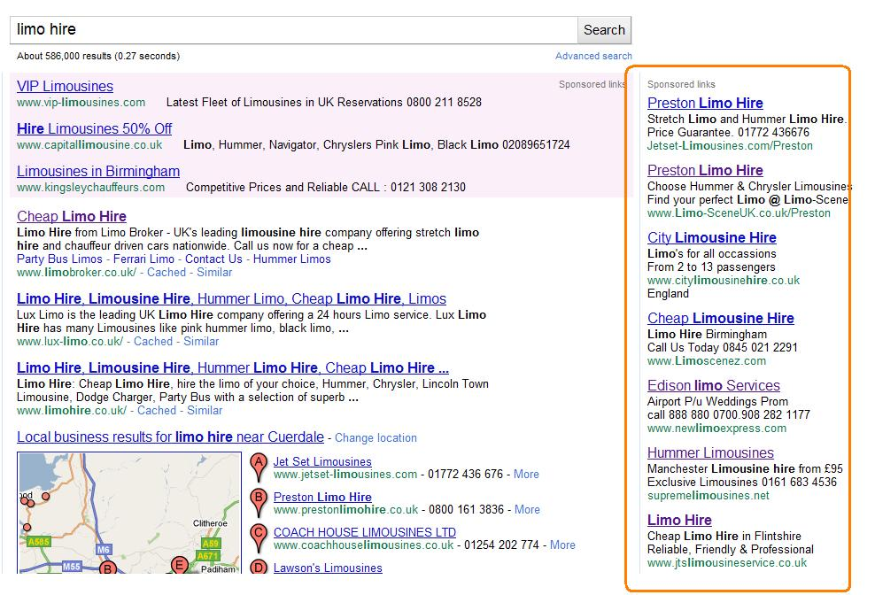

We can see that several advertisers are competing for this keyword as it is very competitive.

Here is an example of a limo company using Google Adwords.

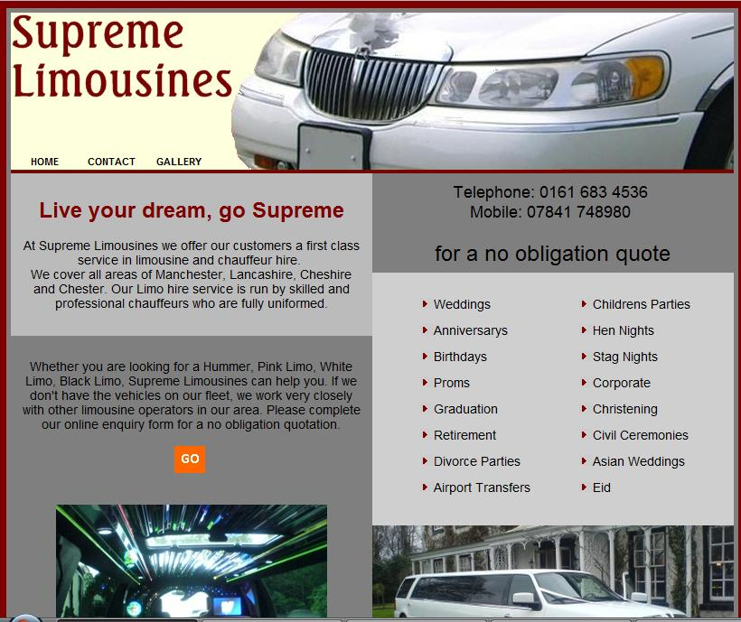

Now this business (as you can see) has a basic website.

The first thing we need to gather is information about this business.

The business is based in Oldham, Lancashire (UK).

Now I am going to see if this business appears on the first page of Google for the keyword “Limo Hire Oldham”.

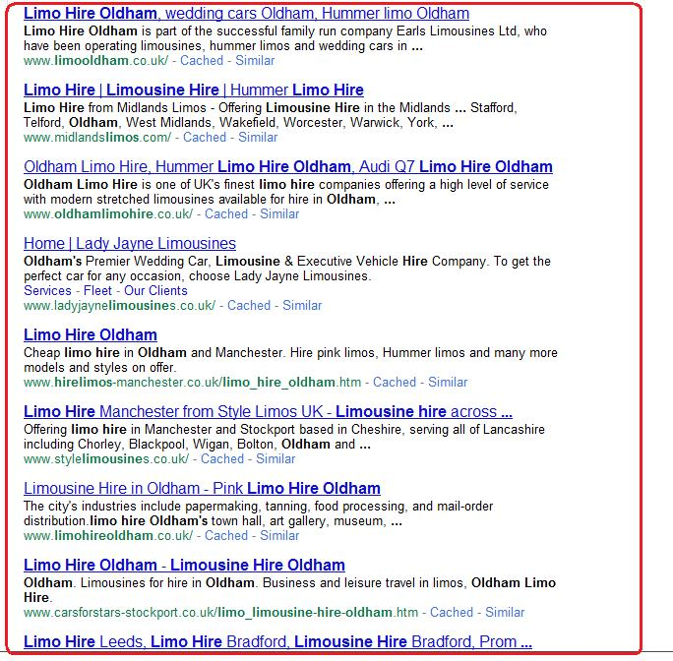

Doing a quick Google search I can see that the limo company’s website is no where to be found on Google.

This is good news.

Now I am going to see how many searches the keyword is generating.

So I head over to [Google Keyword Selector tool](https://adwords.google.com/o/Targeting/Explorer?__u=1000000000&__c=1000000000&ideaRequestType=KEYWORD_IDEAS#search.none).

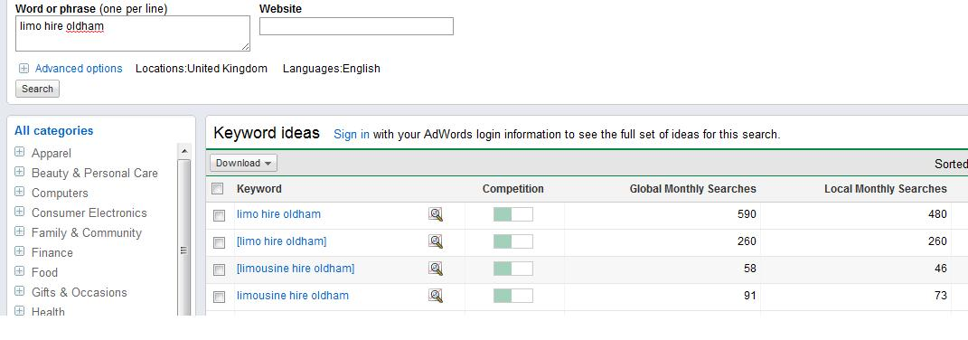

We can see that the phrase has a significant number of searches a month. This is good news.

Now I am going to see what domains names are available for this keyword.

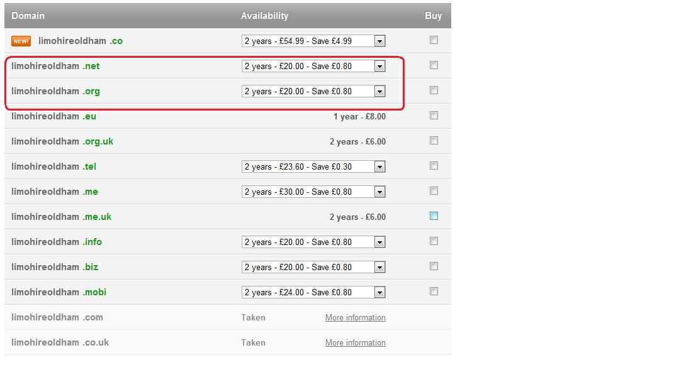

We can see that the .com and .co.uk are taken – no problem.

The .net and .org are available, which is good news.

So register either one (or register both).

The next thing to do is email the business using their contact form.

Here is something you can say to them.

***To whom it might concern,***

*Hi, I noticed you have a website on Limos and you are currently using Google Adwords to drive traffic to your site. Although, this is a good way to drive traffic I have noticed your website is not listed on the first page for your main keyword – “Limo Hire Oldham”.*

*At the moment this keyword is generating typically 500-700 words a month and you are missing out on all this traffic. However, the good news is that I can get your business listed on the first page in no time. So that means if someone types in “Limo Hire Oldham” or “Hire Limo Oldham” your business will be found on the first page – thus saving you a lot of money on the long-term.*

*If you are interested in taking up this offer then please give me a call at xxx-xxx-xxx.*

*I am offering this to all the Limo companies in Oldham and if you do not take this your competitor will be enjoying all the extra clients.*

*I hope to hear from you soon.*

As you can see this is a typical email you can send to business owners. Notice I have mentioned the word “competitor”. When you mention a competitor you will grab their attention very quickly.

The beauty of the website leasing business model is that you do not have to go in with a hard sell. You can simply keep it short and sweet. If you wish to outsource this process then it is pretty straight forward.

Outsourcing would involve hiring someone to cold call for you and close the website leasing contract.

If you are going to be cold calling then you can grab my cold calling report – Outsourcing offline secrets (simply email me if you want to buy this).

**Pricing**

It is up to you on how much you wish to price your website leasing service. I would aim for a **$97-$197 per month price.**

Remember the more residual income you have the more money you will make on a monthly basis.

You might want to charge more for extra features such as Facebook Fanpage and Twitter/Youtube. The more value you add to your leasing website the more money you can charge.

So why not start your own leasing company today?

I hope you enjoyed reading this cash cow report on website leasing and now have lots of ideas on how to go about starting your on site leasing business today.

If you want to see some examples of site leasing companies and their packages you can head over to the following websites.

<http://www.cpcmarketing.co.uk/>

<http://www.websiteleasing.uk.com/>

<http://www.website-renting.com/>

Remember the more action you take the more money you will make.

So start your own site leasing company today!

Imran Naseem

<http://www.ImranNaseem.com>